-istan or poor countries.
22 Discuss THE VARIOUS

POLITICAL.($?) AND
ADMINISTRATIVE
THE WAY OF ECONOMIC DEVELOPMENT THE POOR COUNTRES LIKE PAKISTAN:
SOCIALOGICAL G,'gpup)
Following are the importan t soc idl obstacles
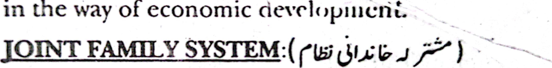
in
of
In many countries like Pakistan this system is still available. All the members of the family live together. Few of them work hard while the-others

do nothing, except with one another. So due to this reason national product reduces.
2. 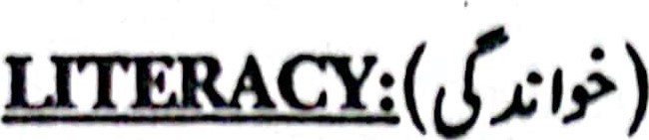
The literacy rate is very low in the under developed countries. It reduces the rate of economic growth. In Pakistan the literacy rate of education is very low. Due to this our farmer(cJt.f) is unable to adopt the modern methods
(4 production. Due to this our labour
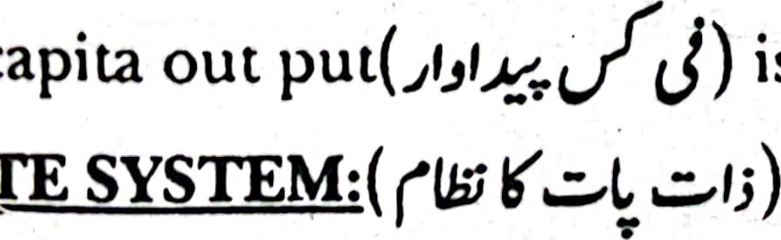
is low.
per
capita

3. CASTE
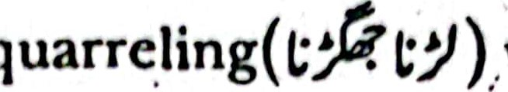
In the under developed countries people are proud about their caste and colour. Every body consideres 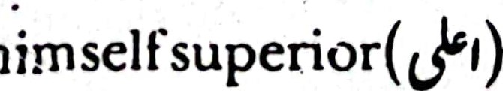than others due to his racial(u^{V} ) Caste system has created hatred(e 3) among the people. This sysem is a in the occupational
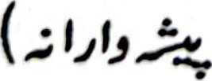) mobility. It is an obstacle in the way of economic development.
1. 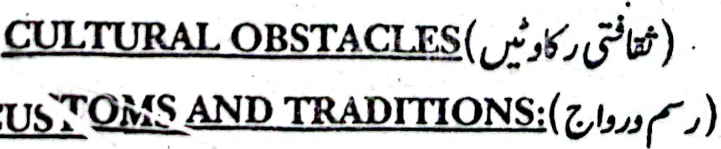
CUST
These are main obstacles in the way oi economic development. In the less developed

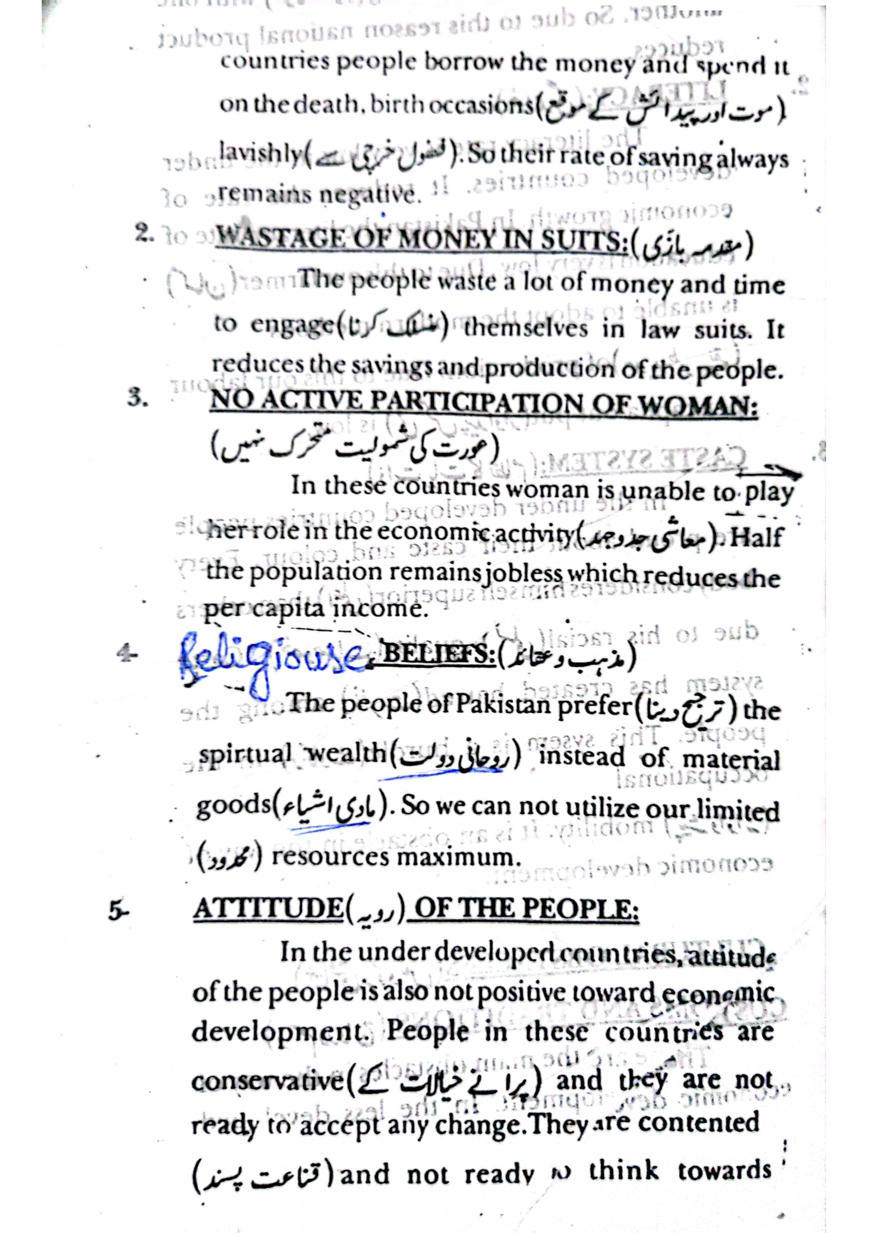

:xawoq- o M01TAs1.1Asrrv«D
ai boqoiovob orlj
development.
at?.uBbfrr1GALtriw -rowo NS,)
thc rate

(Rig)N in the cqgptry.
Rapid -t
the ryssqgntyyaJP)lIB4bjsvamtbeneaFe täÉid Chäh#ß in
th
[Jorijs•q r v
poljfieseoff
governmcn $ 7. 1 t.lt diicohfagqqll(pfrf palnnin.g production and investmelft in th epuptry.

